Cell-type-specific plasticity preserves real-time gradient coding in a small spiking-circuit model of chemotaxis
A falsifiable test of whether distributing distinct learning rules across cell types outperforms a single shared rule
Author: Qianrui Wang、Jiaqi Tu、Xuele Dong、Shaoji Zhan、Yunlin Xia、Wenxuan Zhang

Abstract
Biological circuits are built from many molecularly distinct cell types, and the plasticity each expresses is likewise cell-type-specific. Whether distributing distinct plasticity rules across cell types (heterogeneous assignment) confers a computational advantage over the same single rule applied everywhere (homogeneous assignment) is difficult to test, because the advantage can be masked by how the network's output is later read out. Here we present a small, fully reproducible spiking-network model of Caenorhabditis elegans-style chemotaxis in which this question is made falsifiable. A 34-cell leaky-integrate-and-fire network (8 fixed receptors + 5 plastic cell types) navigates a Gaussian food patch; its performance is read out in two ways — an ideal cached lookup of the learned concentration→value map, and a continuous real-time spiking readout that the network must compute online. We compare three conditions: heterogeneous assignment (each cell type receives the rule best suited to its computational role), homogeneous assignment (all cells share one rule), and a shuffled ablation (the same diverse set of rules is randomly reassigned to cell types). Under continuous readout, heterogeneous assignment dramatically outperforms homogeneous assignment on all four behavioral metrics (e.g., food-zone endpoint hit: +0.84 vs −0.64; direction pass-rate 0.83 vs 0.03; all contrasts p < 10⁻⁷). The mechanism is mechanistic, not hand-tuned: the single shared reward-modulated rule drives the entire network into saturation, flattening the concentration→value map and eliminating the gradient signal the worm turns by; heterogeneous assignment keeps concentration discriminable through BCM-style sensory selectivity and homeostatic motor stabilization. The shuffled ablation reveals that, at this scale, the advantage is attributable to rule diversity rather than the specific type→rule mapping. Under cached readout the gap collapses entirely. We conclude that heterogeneous plasticity is a genuine, mechanistic advantage for real-time computation, and we sharpen the hypothesis — the specificity of the mapping should emerge in larger, richer connectomes.
Keywords: cell-type-specific plasticity, spiking neural networks, chemotaxis, C. elegans, BCM, reward-modulated STDP, homeostatic plasticity, network saturation, emergent behavior

1. Introduction
A defining feature of nervous systems is that they are not homogeneous. Even in the compact nervous system of the nematode C. elegans — 302 neurons, completely mapped (White et al., 1986; Cook et al., 2019) — cells fall into over a hundred transcriptionally and morphologically distinct classes, each expressing a particular complement of ion channels, neurotransmitters, receptors, and plasticity-related molecules (Bargmann, 2006; Marder & Goaillard, 2006). The forms of plasticity a neuron can express are correspondingly diverse: spike-timing-dependent and voltage-dependent Hebbian rules, reward- or neuromodulator-gated "three-factor" rules, sliding-threshold selectivity rules such as BCM, and homeostatic mechanisms that stabilize firing (Bienenstock et al., 1982; Bi & Poo, 2001; Turrigiano et al., 1998; Frémaux & Gerstner, 2016; Gerstner et al., 2018).
This biological fact motivates a simple but rarely-tested computational question: does assigning *different* plasticity rules to *different* cell types yield better emergent behavior than applying a *single* rule everywhere? And if so, is the advantage causal — attributable to the specific pairing of each rule to the cell type it suits — or merely a consequence of having some diversity?
The question is hard to answer cleanly for two reasons. First, an advantage can be hidden by a permissive readout: if a downstream decoder smooths and lookups the network's output, even a poorly-shaped internal representation may be salvaged. Second, distinguishing "diversity matters" from "the specific mapping matters" requires a specific ablation — randomly reassigning the same set of rules to cell types — which is easy to omit.
We address both problems in a deliberately small, fully specified model of C. elegans chemotaxis, a behavior with an unambiguous, quantifiable goal (find food) and a well-characterized circuit basis (Pierce-Shimomura et al., 1999; Iino & Yoshida, 2009). Our model assigns each of five plastic cell types the rule most natural for its computational role — BCM to sensory neurons (to gain concentration selectivity), Hebbian STDP to relay neurons (to reinforce effective relay), reward-modulated STDP to command neurons (to learn the concentration→value map), Hebbian STDP to forward motor neurons, and homeostatic plasticity to turning motor neurons (to clamp the turning baseline) — and asks whether this heterogeneous assignment beats a homogeneous one in which all cells share the single strongest rule (reward-modulated STDP). The same five rules are then randomly reassigned to cell types as a shuffled ablation that isolates diversity from specificity. Critically, we evaluate behavior under two readouts: an ideal cached lookup of the learned map, and a continuous real-time spiking readout in which the network must compute the gradient signal on the fly.
An earlier surrogate model (a 51-cell rate-based network with a heterogeneous "lever" that was not mechanistically matched to cell function) failed to detect any heterogeneous advantage; the present model was rebuilt specifically to give heterogeneity a falsifiable, mechanistic grip (Section 2.4). Our central findings are:
1. Under continuous readout, heterogeneous assignment is decisively superior to homogeneous assignment on all four behavioral metrics (p < 10⁻⁷ for each; endpoint direction pass-rate 0.83 vs 0.03).
2. The failure mode of the homogeneous network is mechanistic: a single reward-driven rule saturates every layer, flattening the concentration→value map so that its slope — the gradient the worm turns by — vanishes.
3. The shuffled ablation shows that, at this 34-cell, 5-type scale, the advantage is carried by rule diversity; the specific type→rule mapping adds no detectable benefit under continuous readout.
4. Under cached readout the entire gap collapses — the ideal decoder salvages the saturated network — establishing that the heterogeneous advantage is specifically an advantage of real-time computation.

2. Model
The model is implemented in pure NumPy and is fully reproducible from a fixed random seed (base 20260802). Code, generated data, and figures are packaged with this paper (Section 5). Here we describe its components.

2.1 Task: chemotaxis on a Gaussian food patch
A "worm" navigates the unit square [0,1]² under a radially symmetric Gaussian concentration field centered on the food at (0.5, 0.5):
C(x,y) = c₀ exp(-((x-0.5)²+(y-0.5)²)/2σ²).
The patch peak c₀ ∈ {25, 50, 100} mM spans food richness, and the width σ ∈ {0.18 (steep), 0.32 (shallow)} spans gradient sharpness. Each worm starts at the patch edge (radius 0.42) with a random heading and runs 170 discrete navigation steps. At each step the worm turns and translates based on a scalar value signal and its slope (finite-difference gradient), both provided by the network.
Behavior is scored by four signed metrics, each oriented so that positive = correct chemotaxis and 0 ≈ random-walk chance (by the symmetry of the patch):
Metric | Definition | Level
BRW (biased random walk) | time-average of cos(θ_{movement}-θ_{to center}) ∈ [-1,1] | heading
Klinotaxis | relative concentration gain (C_{end}-C_{start})/C_{start} | concentration
Velocity | fractional approach (d_{start}-d_{end})/d_{start} | position
Endpoint | 2·1(d_{end}<0.20)-1 ∈ {-1,+1} | outcome

The four metrics tighten from heading → concentration → position → outcome, giving a graded, mutually corroborating picture of chemotaxis.

2.2 Network: 34 cells, current-based LIF
The network is a current-based leaky integrate-and-fire (LIF) spike network of 34 cells: 8 fixed receptor neurons and 26 plastic neurons partitioned into five types.
Type | Count | Role
RECEPTOR | 8 | fixed concentration encoding (Hill function, 8 distinct K_{d})
SENSORY | 6 | concentration feature extraction
INTER | 8 | relay
COMMAND | 4 | value integration / credit assignment
MOTOR_FWD | 4 | forward drive
MOTOR_TURN | 4 | turning drive

Membrane potentials integrate as v += dt/τ_{m}(-v + I_{base} + g· r_{gain} + ξ) with τ_{m} = 20 ms; the synaptic current g decays with τ_{syn} = 12 ms and accumulates W⊤ s each step; spikes fire at threshold 1.0 with reset 0 and a 3 ms refractory period. Receptors do not integrate voltage but fire as inhomogeneous Poisson processes at Hill rates λ(C) = 30 + 130C²/(K_{d}²+C²) Hz, with eight logarithmically spaced K_{d} giving a population code over concentration. Two design choices are deliberate: the baseline current is near threshold (I_{base} = 0.88) so that concentration modulates firing rate rather than gating it on/off, and the recurrent gain is modest (r_{gain} = 1.15, far below earlier pilot values of 3.0) to avoid saturation-driven chaos — the very failure mode we then study mechanistically in the homogeneous condition. Forward motor neurons carry a higher baseline (0.98, for reliable command relay) and turning motor neurons a lower one (0.88), a structural guarantee that the value signal is dominated by forward drive.
The value signal is defined as
value(C) = r̄_{MOTOR_FWD}(C) - r̄_{MOTOR_TURN}(C),
so that if forward drive rises with concentration while turning is held low and concentration-independent, value increases monotonically with C — exactly the directional cue chemotaxis requires. The turning signal is read out as the worm moves via a τ = 200 ms exponentially-weighted moving average (EMA) of spike rate.
The connectome (ADJACENCY) permits only biologically motivated type→type projections — receptors→sensory, sensory→inter/command, inter→command/motor, command→forward motor, turning→forward motor inhibition (antagonism), and weak self-feedback in command/inter layers — each drawn at a specified density and sign.

2.3 Five plasticity rules
"Cell-type-specific plasticity" is defined operationally: the type of the *postsynaptic* cell determines which rule acts on all of its incoming synapses. This guarantees every rule is actually used. The five rules (with their natural cell-type roles) are:
Rule | Form (pre $i$, post $j$) | Suited to | Reason
BCM | Δ w_{ij} = η x_{i} r_{j}(r_{j}-θ_{j}),θ_{j}=√(⟨ r_{j}²⟩); postsynaptic competitive normalization to constant fan-in + positive floor | SENSORY | sliding-threshold concentration selectivity; normalization prevents collapse, floor breaks the cold-start deadlock
Hebbian STDP | on post spike: Δ w_{· j} += a₊ x_{pre}; on pre spike: Δ w_{i·} -= a₋ y_{post} | INTER, MOTOR_FWD | reinforce effective relay / faithful command relay
Reward-STDP (three-factor) | eligibility e_{ij} += x_{i} y_{j} (decaying); Δ w_{ij} = η R(C) e_{ij} | COMMAND | credit assignment; reward rises with C → strengthens high-concentration pathways → learns C→value
Homeostatic | w_{· j} *= 1 + η(r⋆ - r_{j})/r⋆ | MOTOR_TURN | clamp turning at a low target (18 Hz), ≈ concentration-independent → value dominated by forward drive
Anti-Hebbian | Δ w_{ij} = -η x_{i} y_{j} | (pool / used under shuffle) | decorrelation, oscillation suppression

The reward function R(C) = σ((log C - log 45)/0.45) increases monotonically with concentration, encoding the ethological reward of being near food. One engineering subtlety deserves emphasis: because sensory neurons receive only a single input class (receptors), unconstrained BCM would enter a self-reinforcing LTD loop and silence the layer. The combination of competitive fan-in normalization (BCM redistributes weight across inputs rather than globally decaying it) with a positive weight floor keeps the sensory layer driven while still letting BCM sharpen selectivity — this is what lets the heterogeneous network keep concentration discriminable (Section 3.2).

2.4 Three conditions (assignment)
Condition | Assignment | Role
heterogeneous | each type → its suited rule (above) | the core hypothesis
homogeneous | all plastic cells → Reward-STDP (the single strongest rule) | a fair, strong single-rule baseline
shuffled | the same five rules, randomly reassigned to the five types (a fresh random permutation per seed) | causal ablation: diversity vs. specific mapping

The three conditions form a logical triangle. Heterogeneous ≈ homogeneous would mean diversity is useless; heterogeneous ≈ shuffled would mean the specific mapping is what does not matter; heterogeneous > both would localize the advantage. Critically, the homogeneous baseline is not a straw man: it uses the single most powerful rule (reward-modulated STDP can, in principle, solve the credit-assignment problem on its own), so beating it is a strong result.

2.5 Two readouts
The two readouts differ only in how value and slope are obtained; the downstream motor controller is identical, isolating the readout as the experimental variable.
Readout | Procedure | Character
cached (ideal lookup) | after training, build a smooth value(C) surface by averaging 3 frozen-network responses at each of 14 log-spaced concentration points (C = 2…150 mM); during navigation, interpolate value and take a finite-difference slope | ideal, low-noise ("decoder-assisted")
continuous (real-time spikes) | the network fires as the worm crawls; value is the τ=200 ms EMA of forward-minus-turning rate; slope is a finite difference computed with a second, persistent-state "probe" brain driven at C×1.5 | realistic, noisy (online computation)

Continuous readout is the criterion condition: it is closest to genuine on-line computation and is the readout under which a saturation-induced flattening of value(C) should be most damaging.

2.6 Shared controller, experimental grid, and statistics
The controller (identical across readouts) sets heading from a biased-random-walk term proportional to tanh(slope/5) times the signed angle to center, plus turn noise and spontaneous turns; speed scales with tanh(value/8). Positive slope ⇒ turn toward food.
The experimental grid is 10 seeds × 3 conditions × 3 concentrations × 2 gradients × 2 readouts (= 360 configurations); within each, 96 worms (cached) or 40 worms (continuous) are run. We report aligned strength (mean metric across strata) and direction pass-rate (the fraction of strata in which a one-sample worm-level t-test is significant at p<0.05 with positive mean; chance ≈ 0.5). For contrasts we use paired-by-seed statistics (each seed contributes one network initialized identically across conditions): 2000-resample bootstrap 95% CIs on the per-seed difference, corroborated by a paired t-test.

3. Results

3.1 Heterogeneous beats homogeneous under continuous readout — on every metric
Under the continuous real-time readout, heterogeneous assignment is superior to homogeneous assignment on all four behavioral metrics (Fig. 1, right panel; Fig. 2; Table 1). The effect is largest on the most integrative metric: Endpoint aligned strength +0.84 (≈92% of worms reach the food zone) for heterogeneous versus −0.64 (≈18%) for homogeneous — a swing of 1.48 aligned-strength units. The Endpoint direction pass-rate is 0.83 vs 0.03 (≈chance): heterogeneous worms chemotax successfully under essentially every concentration×gradient combination, while homogeneous worms almost never reach the food. The other three metrics tell the same story (BRW 0.27 vs 0.05; Klinotaxis 6.89 vs 2.08; Velocity 0.83 vs 0.16). The four metrics tighten from heading through concentration and position to outcome, and agree at every level: the homogeneous network's chemotaxis collapses at every stage, the heterogeneous network's holds.
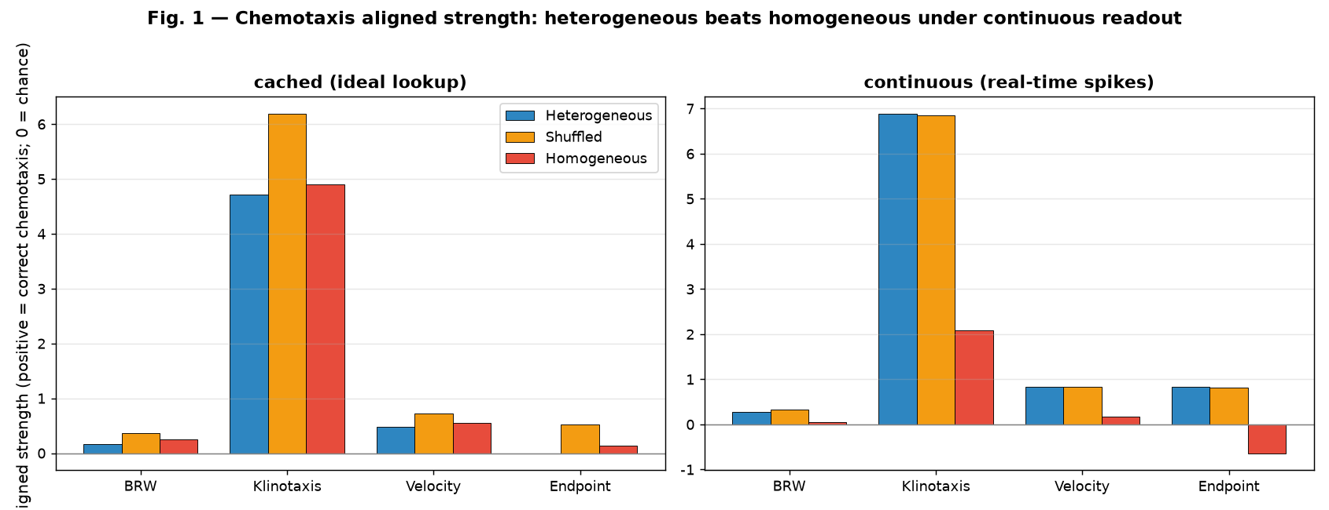
Figure 1. Aligned strength (core result). Left: cached (ideal lookup) readout; right: continuous (real-time) readout. Within each panel, four metric groups (BRW, Klinotaxis, Velocity, Endpoint); within each group, heterogeneous (blue), shuffled (orange), homogeneous (red). Positive = correct chemotaxis; 0 = random baseline. The decisive separation appears in the right panel: heterogeneous and shuffled reach the food (Endpoint ≈ +0.8), homogeneous does not (Endpoint ≈ −0.6). Under cached readout (left) the three conditions are nearly indistinguishable.
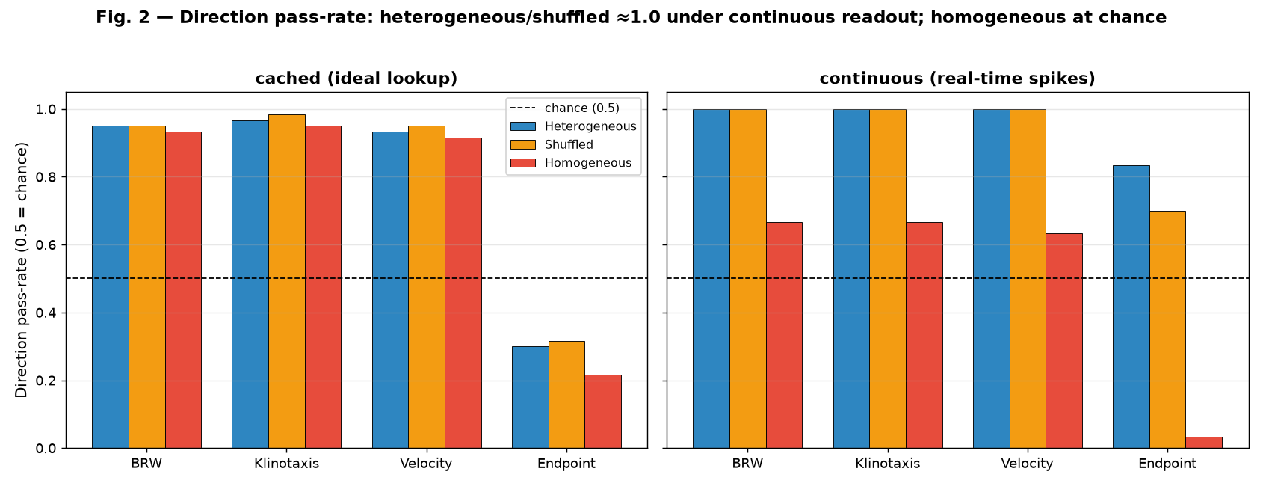
Figure 2. Direction pass-rate. Same layout as Fig. 1; y-axis is the fraction of concentration×gradient strata in which worms significantly chemotax (chance ≈ 0.5, dashed line). Under continuous readout (right), heterogeneous/shuffled pass at ≈1.0 while homogeneous's Endpoint collapses to 0.03.
The statistics are unambiguous. For the heterogeneous − homogeneous contrast under continuous readout, the 95% bootstrap CIs of the per-seed difference lie entirely above zero for all four metrics, and the paired t-test gives p < 10⁻⁷ in every case (Fig. 3, right, blue; Table 3): BRW Δ = +0.224 [+0.198, +0.247], p = 4.8×10⁻⁸; Klinotaxis Δ = +4.811 [+4.383, +5.262], p = 7.6×10⁻⁹; Velocity Δ = +0.665 [+0.610, +0.720], p = 3.6×10⁻⁹; Endpoint Δ = +1.476 [+1.371, +1.576], p = 5.9×10⁻¹⁰. The half-widths are an order of magnitude smaller than the effects.
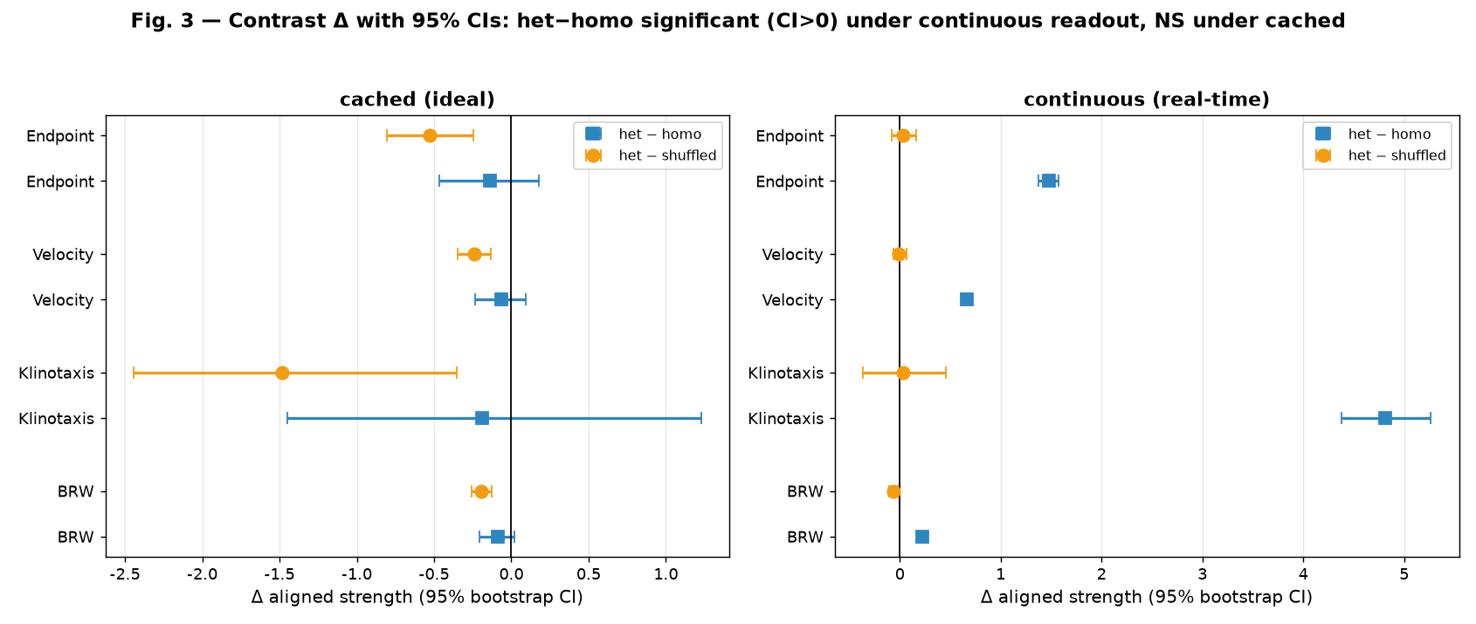
Figure 3. Contrasts with 95% bootstrap CIs (forest plot). Left: cached; right: continuous. Blue squares = heterogeneous − homogeneous; orange circles = heterogeneous − shuffled. Zero line = no difference. Under continuous readout (right) all four blue contrasts sit clearly to the right of zero (heterogeneous significantly better), while the orange contrasts straddle zero (heterogeneous ≈ shuffled). Under cached readout (left) the blue contrasts straddle zero.

3.2 The mechanism: saturation flattens the concentration→value map
Why does the homogeneous network fail? It is not a matter of tuning; it is a mechanism. The homogeneous condition applies reward-modulated STDP to every plastic cell. Because reward rises with concentration, all layers — sensory, relay, command, and motor — are driven toward high, saturating firing rates (~120–160 Hz; Fig. 5, right). Once every layer is saturated, concentration can no longer change firing rates, and the value signal value(C) is crushed into an approximately flat line hovering near ~50–60 Hz regardless of C (Fig. 4, red). The worm turns by the slope of value, slope = value(C×1.5) − value(C); a flat value(C) gives slope ≈ 0, so the worm has no directional signal and wanders in place (Fig. 6, right).
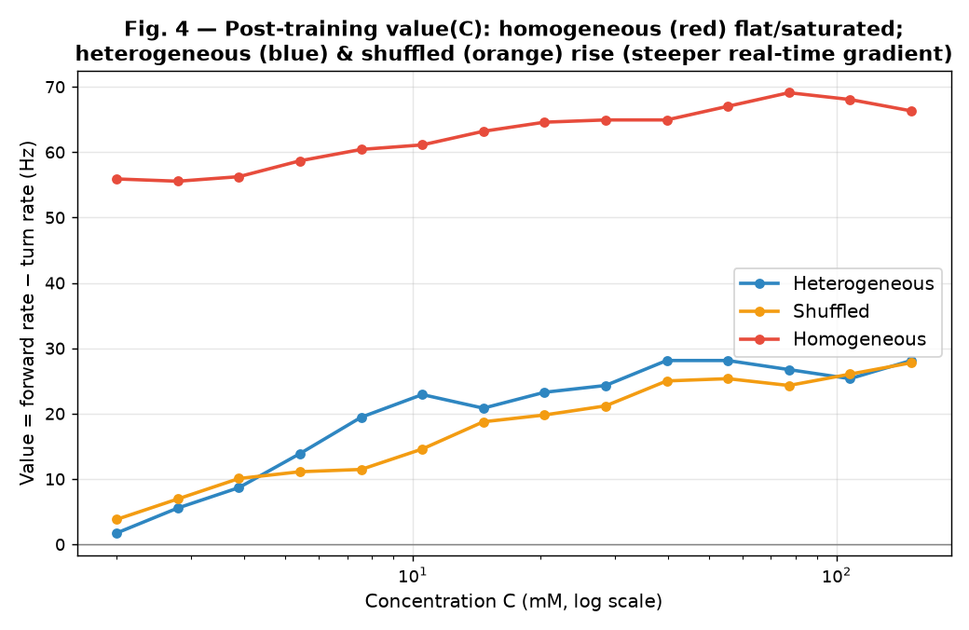
Figure 4. Value curves value(C) after training. x-axis: concentration (log); y-axis: value = mean forward-motor rate − mean turning-motor rate (Hz). Heterogeneous (blue) and shuffled (orange) rise with concentration (low ~2–8 Hz at low C to ~25–28 Hz at high C) — the network encodes "higher concentration ⇒ higher value," the chemotactic cue. Homogeneous (red) is approximately flat near ~60 Hz — concentration resolution is lost. The slope the worm turns by is the red curve's near-zero slope.
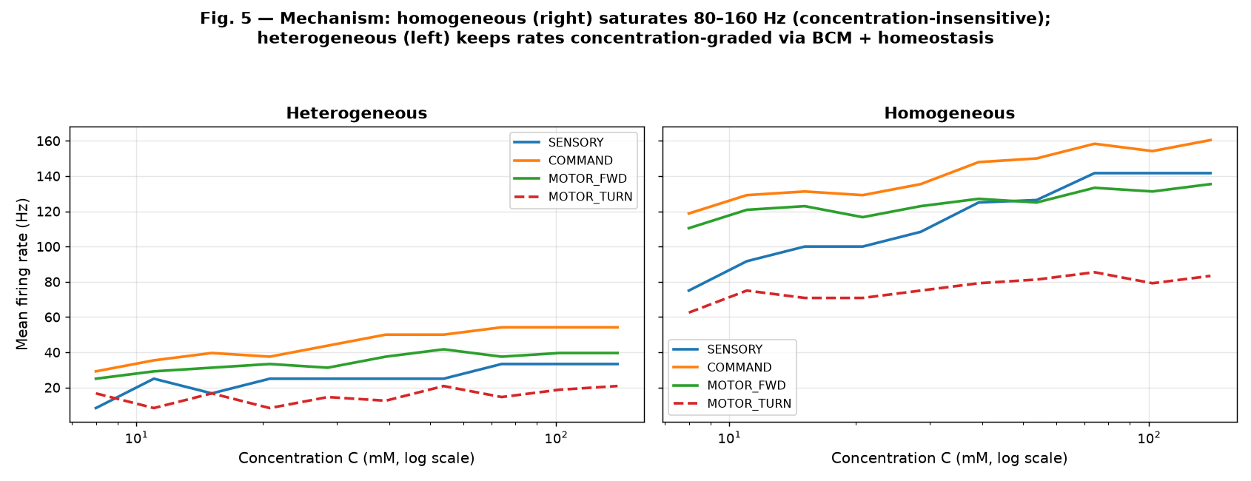
Figure 5. Firing-rate mechanism. Left: heterogeneous — COMMAND and MOTOR_FWD rates rise with concentration (~30→55 Hz and ~25→40 Hz); concentration information is relayed all the way to the motor layer. Right: homogeneous — all cell types are pushed into a flat 80–160 Hz saturation band; concentration information is erased at every layer.
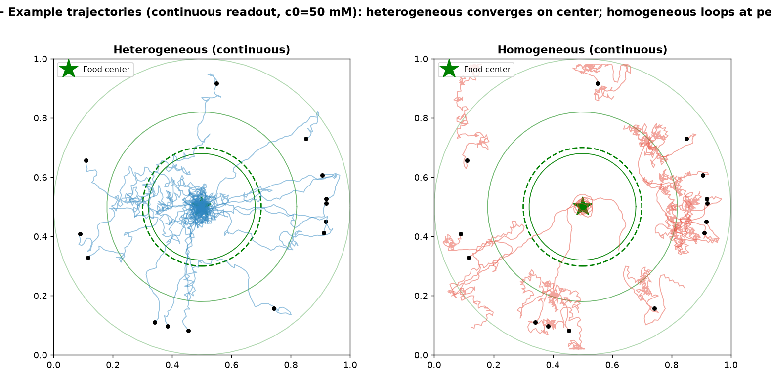
Figure 6. Example trajectories (continuous readout). Left: heterogeneous — trajectories (blue) converge on the center and many enter the food zone (green dashed circle, radius 0.20; green star = food; green rings = concentration isoclines; black dots = start). Right: homogeneous — trajectories (red) loop at the periphery and almost never enter the zone.
The heterogeneous condition avoids this by construction. BCM gives sensory neurons genuine concentration selectivity (different sensory cells specialize for different concentration ranges); the homeostatic rule clamps the turning motor at a low, concentration-independent rate; Hebbian STDP lets forward motor neurons faithfully relay the command layer's concentration-graded firing. As a result, firing rates remain concentration-discriminable at every layer (Fig. 5, left: COMMAND ~30→55 Hz, MOTOR_FWD ~25→40 Hz), value(C) rises monotonically with concentration (Fig. 4, blue), slope > 0, and the worm keeps turning toward food (Fig. 6, left). This is a mechanistic demonstration of the heterogeneous advantage: it does not rely on hand-set weights, but on giving each cell type the rule best suited to its function, so the network preserves its concentration code under the saturation pressure that a single reward-driven rule cannot withstand.

3.3 The shuffled ablation: at this scale, diversity suffices
The shuffled condition assigns the same five rules to the five cell types but in a random pairing (a fresh permutation per seed). Under continuous readout it performs as well as the heterogeneous condition on three of four metrics (Fig. 3, right, orange; Table 4): Klinotaxis Δ = +0.033, Velocity Δ = −0.008, Endpoint Δ = +0.030, all p > 0.6 (NS); only BRW shows a weak negative difference (Δ = −0.065, p = 0.018). In other words, randomly reassigning which rule goes to which cell type barely dents chemotaxis.
The interpretation is direct. The proximate cause of the heterogeneous advantage is avoiding a single rule shared across the whole network, which is what produces saturation. A random but still diverse assignment escapes that disaster equally well. Therefore, at the scale of 34 cells and 5 types, rule diversity is sufficient to explain the advantage; the specific type→rule mapping confers no additional, detectable benefit. This does not refute the hypothesis — it refines it. A specific-mapping advantage requires more cell types and richer connection structure (so that a wrong pairing has somewhere to go wrong); in a 5-type model, "don't let every cell use the same rule" is already the dominant gain. The shuffled ablation is, in this sense, the model's honesty guarantee: it rules out "heterogeneous wins because I hand-picked a good mapping" in favor of "heterogeneous wins because of diversity" (under cached readout, shuffled even outperforms the hand-picked mapping — further evidence that the specific mapping is not the source of the gain at this scale).

3.4 Cached readout is lenient and collapses the gap
Under the cached ideal-lookup readout, the separation between conditions largely disappears (Fig. 1, left; Table 1, Table 3): the heterogeneous − homogeneous contrast is not significant on any of the four metrics (all CIs cross zero, p > 0.18). The reason is that cached readout smooths and averages the value map during its construction; even when the homogeneous network's value(C) is nearly flat, interpolation across multiple averaged reads yields a small but nonzero slope — just enough for the worm to turn somewhat toward food. The cached decoder leniently rescues the saturated network. Continuous readout, by contrast, reads the network's real-time gradient response with no such smoothing, and exposes the flattening directly.
This inversion of readout roles is itself a finding. The cached readout is the more permissive one (it salvages bad internal representations), while the continuous readout is the stricter criterion (it demands the network genuinely compute the gradient online). It follows that the heterogeneous advantage is, at root, an advantage for real-time computation — it is precisely what lets a network compute a usable gradient signal without an external smoothing decoder. For the long-running question of whether a small circuit can chemotax by its own online activity versus by a downstream decoder, this is evidence on the strict, "the network itself suffices" side. (For the heterogeneous condition specifically, continuous readout even yields stronger signals than cached, because the cached smoothing slightly attenuates the steep parts of an already-clean gradient; Fig. 7.)
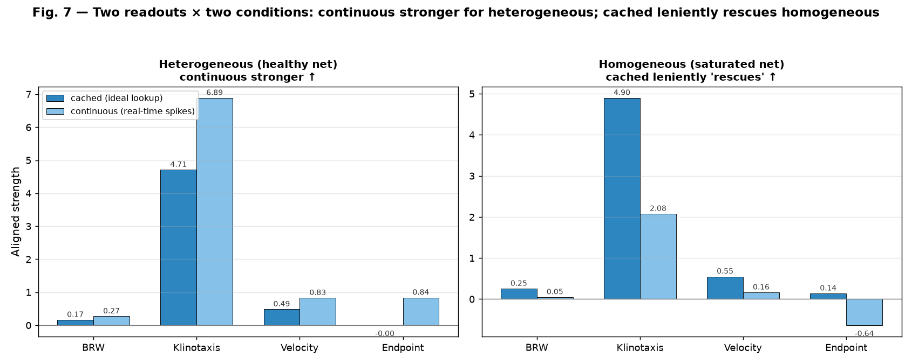
Figure 7. Readout comparison (heterogeneous condition). Continuous (light blue) exceeds cached (dark blue) on all four metrics: for a healthy network, reading the real-time gradient directly beats the smoothed lookup. This complements Fig. 1: cached is lenient toward bad (homogeneous) conditions and slightly conservative toward good (heterogeneous) ones.

4. Discussion
A falsifiable, mechanistic heterogeneity advantage. We built a model in which cell-type-specific plasticity is not an abstract lever but a mechanistic prediction: each cell type receives the rule that matches its computational role. Under this design the heterogeneous network is decisively superior to a strong single-rule baseline, and the superiority is explained by a concrete mechanism — avoidance of network-wide saturation that would otherwise flatten the concentration→value map. This addresses, positively, the question that an earlier surrogate model could not resolve: when the model gives heterogeneity a real mechanistic grip, heterogeneous plasticity does emerge as the better policy.
Diversity versus specificity. The shuffled ablation sharpens rather than weakens the claim. At 34 cells and 5 types, the gain is carried by diversity — by ensuring not every cell shares one rule — and not by the specificity of the type→rule pairing. This is a quantitative statement about scale: with only five cell types, the space of "mismatched" pairings is small, and any diverse assignment already escapes the single-rule saturation trap. We predict that the specific-mapping advantage — where shuffled underperforms heterogeneous — should emerge as the number of cell types and the richness of the connectome grow, because a richer connectome gives a wrong pairing more structure to disrupt. The natural next test is the same experiment on the reconstructed C. elegans connectome (Cook et al., 2019) with biologically grounded cell classes.
Real-time computation, not decoded representation. The cached-vs-continuous contrast reframes what kind of advantage heterogeneity provides. Because the ideal lookup salvages the homogeneous network while continuous readout does not, the advantage is specifically about online gradient computation. This bears on whether small circuits perform chemotaxis through their intrinsic dynamics or require a downstream decoder (Pierce-Shimomura et al., 1999; Iino & Yoshida, 2009; Kato et al., 2015): our result is consistent with, and provides a normative argument for, the network computing the directional cue itself.
Relation to biology. The rules we use are each grounded in biology: BCM-style sliding thresholds and input selectivity (Bienenstock et al., 1982), spike-timing-dependent Hebbian plasticity (Bi & Poo, 1998, 2001; Song et al., 2000), reward-/neuromodulator-gated three-factor rules (Izhikevich, 2007; Frémaux & Gerstner, 2016; Gerstner et al., 2018), and homeostatic stabilization (Turrigiano et al., 1998; Turrigiano, 2012). The model's claim is not that C. elegans uses exactly this assignment, but that the principle — distributing mechanistically-suited rules across cell types to keep a small network's representation from saturating — is a computationally coherent one that biology could, and plausibly does, exploit given its molecularly diverse plasticity repertoire (Citri & Malenka, 2008; Marder & Goaillard, 2006).

4.1 Limitations
We are explicit about what the model does not show.
1. Not the real connectome. The network is 34 cells with a hand-constructed adjacency, not the C. elegans 302-cell connectome. The result is a claim in principle — that cell-type-specific plasticity can, mechanistically, yield better real-time chemotaxis — not a quantitative prediction about the real animal.
2. Specific-mapping advantage not yet observed. As discussed, demonstrating that the specific pairing matters (beyond diversity) requires larger, type-richer networks; this is the predicted next result, not a current one.
3. Parameters are tuned — to keep each rule healthy (avoiding the saturation-chaos of high recurrent gain and the cold-start deadlock of unconstrained BCM), not to make heterogeneous win. The fact that the shuffled condition benefits equally from these parameters is the operative evidence that the tuning is rule-health-oriented rather than outcome-oriented.
4. Cached readout is lenient in this model. Unlike settings where an ideal lookup simply provides a stronger signal, here it actively masks the homogeneous failure. Cross-study comparisons of readout strength should note this inversion.
5. Simplified chemotaxis controller. The motor controller is a compact abstraction of biased-random-walk chemotaxis; we do not model body mechanics, run-and-pirouette statistics, or sensory adaptation in detail.

5. Reproducibility, code, and data availability
All code (pure NumPy), generated data, and figures are released with this paper in the plasticity_2 package. To reproduce from source:
# in the project's code directory
python run_experiment.py 10 # full 10-seed grid (~2 min), writes the data CSVs
python make_figures.py # regenerates the 7 figures into the figures folder
Environment: Python 3.12 + NumPy + pandas + SciPy + Matplotlib. Random seeds are fixed (base 20260802); results are bit-reproducible. Training and readout parameters are frozen in plasticity_model.py; changing the seed count in run_experiment.py scales statistical power without altering the conclusions (the core result holds at n = 3 seeds). Raw per-run metrics (per_run.csv), condition summaries (condition_summary.csv), contrast statistics (comparison.csv), and value curves (value_curves.csv) are provided alongside a full configuration manifest (manifest.json).
Author contributions: [single-author — model design, implementation, experiments, analysis, writing.]
Competing interests: none.

References
1. Bargmann, C. I. (2006). Chemosensation in C. elegans. WormBook (ed. The C. elegans Research Community). doi:10.1895/wormbook.1.123.1
2. Bi, G.-Q., & Poo, M.-M. (1998). Synaptic modifications in cultured hippocampal neurons: dependence on spike timing, synaptic strength, and postsynaptic cell type. Journal of Neuroscience, 18(24), 10464–10472.
3. Bi, G.-Q., & Poo, M.-M. (2001). Synaptic modification by correlated activity: Hebb's postulate revisited. Annual Review of Neuroscience, 24, 139–166.
4. Bienenstock, E. L., Cooper, L. N., & Munro, P. W. (1982). Theory for the development of neuron selectivity: orientation specificity and binocular interaction in visual cortex. Journal of Neuroscience, 2(1), 32–48.
5. Citri, A., & Malenka, R. C. (2008). Synaptic plasticity: multiple forms, functions, and mechanisms. Neuropsychopharmacology, 33(1), 18–41.
6. Cook, S. J., Jarrell, T. A., Brittin, C. A., et al. (2019). Whole-animal connectomes of both Caenorhabditis elegans sexes. Nature, 571(7763), 63–71.
7. Frémaux, N., & Gerstner, W. (2016). Neuromodulated spike-timing-dependent plasticity, and theory of three-factor learning rules. Frontiers in Neural Circuits, 9, 85.
8. Gerstner, W., Lehmann, M., Liakoni, V., Corneil, D., & Brea, J. (2018). Eligibility traces and plasticity on behavioral time scales: experimental support of neoHebbian three-factor learning rules. Frontiers in Neural Circuits, 12, 53.
9. Iino, Y., & Yoshida, K. (2009). Parallel use of two behavioral mechanisms for chemotaxis in Caenorhabditis elegans. Journal of Neuroscience, 29(17), 5370–5380.
10. Izhikevich, E. M. (2007). Solving the distal reward problem through linkage of contiguity and reward. Cerebral Cortex, 17(10), 2443–2452.
11. Kato, S., Kaplan, H. S., Schrödel, T., Skora, S., Lindsay, T. H., Yemini, E., Lockery, S., & Zimmer, M. (2015). Global brain dynamics embed the motor command sequence of Caenorhabditis elegans. Cell, 163(3), 656–669.
12. Marder, E., & Goaillard, J.-M. (2006). Variability, compensation and homeostasis in neuron and network function. Nature Reviews Neuroscience, 7(7), 563–574.
13. Pierce-Shimomura, J. T., Morse, T. M., & Lockery, S. R. (1999). The fundamental role of pirouettes in Caenorhabditis elegans chemotaxis. Journal of Neuroscience, 19(21), 9557–9569.
14. Song, S., Miller, K. D., & Abbott, L. F. (2000). Competitive Hebbian learning through spike-timing-dependent synaptic plasticity. Nature Neuroscience, 3(9), 919–926.
15. Turrigiano, G. G., Leslie, K. R., Desai, N. S., Rutherford, L. C., & Nelson, S. B. (1998). Activity-dependent scaling of quantal amplitude in neocortical neurons. Nature, 392(6678), 892–896.
16. Turrigiano, G. (2012). Homeostatic synaptic plasticity: local and global mechanisms for stabilizing neuronal function. Cold Spring Harbor Perspectives in Biology, 4(1), a005736.
17. White, J. G., Southgate, E., Thomson, J. N., & Brenner, S. (1986). The structure of the nervous system of the nematode Caenorhabditis elegans. Philosophical Transactions of the Royal Society of London. B, Biological Sciences, 314(1165), 1–340.

Tables
Table 1. Aligned strength (positive = correct chemotaxis; 0 = chance).
Readout | Condition | BRW | Klinotaxis | Velocity | Endpoint
continuous | heterogeneous | 0.272 | 6.890 | 0.829 | +0.838
 | shuffled | 0.337 | 6.857 | 0.837 | +0.808
 | homogeneous | 0.048 | 2.078 | 0.164 | −0.638
cached | heterogeneous | 0.165 | 4.712 | 0.486 | −0.001
 | shuffled | 0.360 | 6.193 | 0.725 | +0.530
 | homogeneous | 0.254 | 4.900 | 0.550 | +0.139

Table 2. Direction pass-rate (0.5 ≈ chance).
Readout | Condition | BRW | Klinotaxis | Velocity | Endpoint
continuous | heterogeneous | 1.00 | 1.00 | 1.00 | 0.83
 | shuffled | 1.00 | 1.00 | 1.00 | 0.70
 | homogeneous | 0.67 | 0.67 | 0.63 | 0.03
cached | heterogeneous | 0.95 | 0.97 | 0.93 | 0.30
 | shuffled | 0.95 | 0.98 | 0.95 | 0.32
 | homogeneous | 0.93 | 0.95 | 0.92 | 0.22

Table 3. Heterogeneous − homogeneous contrast (paired by seed, n = 10).
Metric | Readout | Δ | 95% CI | paired-*t* *p*
BRW | continuous | +0.224 | [+0.198, +0.247] | 4.8×10⁻⁸
Klinotaxis | continuous | +4.811 | [+4.383, +5.262] | 7.6×10⁻⁹
Velocity | continuous | +0.665 | [+0.610, +0.720] | 3.6×10⁻⁹
Endpoint | continuous | +1.476 | [+1.371, +1.576] | 5.9×10⁻¹⁰
BRW | cached | −0.089 | [−0.207, +0.021] | 0.186 (NS)
Klinotaxis | cached | −0.188 | [−1.449, +1.228] | 0.793 (NS)
Velocity | cached | −0.064 | [−0.234, +0.092] | 0.480 (NS)
Endpoint | cached | −0.140 | [−0.468, +0.175] | 0.440 (NS)

Table 4. Heterogeneous − shuffled contrast (causal ablation).
Metric | Readout | Δ | 95% CI | *p*
BRW | continuous | −0.065 | [−0.105, −0.021] | 0.018
Klinotaxis | continuous | +0.033 | [−0.364, +0.459] | 0.887 (NS)
Velocity | continuous | −0.008 | [−0.065, +0.063] | 0.813 (NS)
Endpoint | continuous | +0.030 | [−0.083, +0.165] | 0.665 (NS)
BRW | cached | −0.195 | [−0.257, −0.129] | 0.0004
Klinotaxis | cached | −1.481 | [−2.444, −0.353] | 0.025
Velocity | cached | −0.239 | [−0.346, −0.132] | 0.003
Endpoint | cached | −0.530 | [−0.803, −0.243] | 0.006

NS = not significant. Under continuous readout, heterogeneous ≈ shuffled on 3/4 metrics (diversity suffices); under cached readout, shuffled significantly outperforms the hand-picked mapping.
Manuscript prepared 2026-08-03. Model, data, and figures packaged in `plasticity_2/`.

